Sualeh Abbas 10303

Ayesha Shahid 10278

Lab 2: Implementing Decision Instructions in RISC V Assembly Language

Task 1:
Type the codes in Listings 3 and 4 in the assembler editor and then in the simulator look at their binary:
- The beq and bne instructions are stored in the SB format with their 32-bit binary. Look it up and try to find out what values their different fields contain.
- Looking at the binary formats, find out how do the labels are stored in the 32-bit instruction. Compare the label values stored inside the instruction to the code and try to guess how the assembler stores the jump addresses inside the instruction. (Hint: it uses a PC-relative scheme) Refer to following figures (from book page 119) to see encoding of instructions.
Note: To test listing 4, ld will be replaced by lw and for computation of address, offset should be obtained by i*4 i.e., shift left by 2 instead of

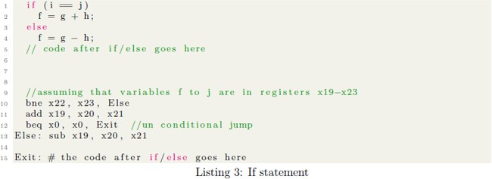
For Listing 3

BEQ
01000 | 00000 | 00000 | 000 | 01000 | 1100011

BNE
01100 | 10110 | 1011 | 001 | 00000 | 1100011

For listing 4
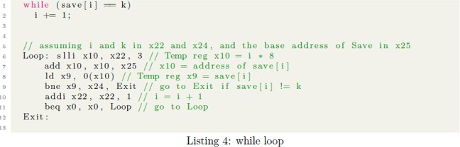

BEQ
10100 | 00000 | 00000 | 000 | 10100 | 1100011

BNE
01100 | 01001 | 11000 | 001 | 01100 | 1100011

Task 2:
The switch statement is similar to if/else statements. Write the equivalent RISC-V assembly code for Listing 5.
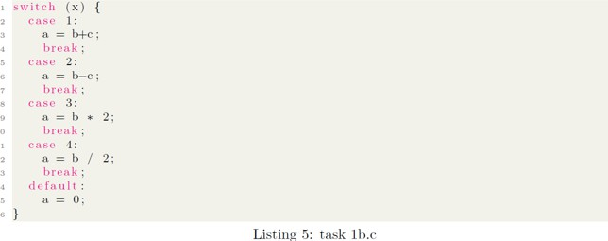
Assume that the variables x, a, b & c are signed integers and stored in x20, x21, x22, x23 respectively. Make sure to first assign suitable values for b and c first.

Code:
.text
.globl
main:
li x1, 1 #case1
li x2, 2 #case2
li x3, 3 #case3
li x4, 4 #case4

li x22, 20 # b
li x23, 21 # c
li x20, 1 #x
li x24, 2 #integer value
beq x20, x1, case1
beq x20, x2, case2
beq x20, x3, case3
beq x20, x4, case4

li x21, 0

case1:
add x21, x22, x23
beq x0, x0, exit
case2:
sub x21, x22, x23
beq x0, x0, exit
case3:
mul x21, x22, x24
beq x0, x0, exit
case4:
div x21, x22, x24
beq x0, x0, exit
exit:
Output:

Case 1:
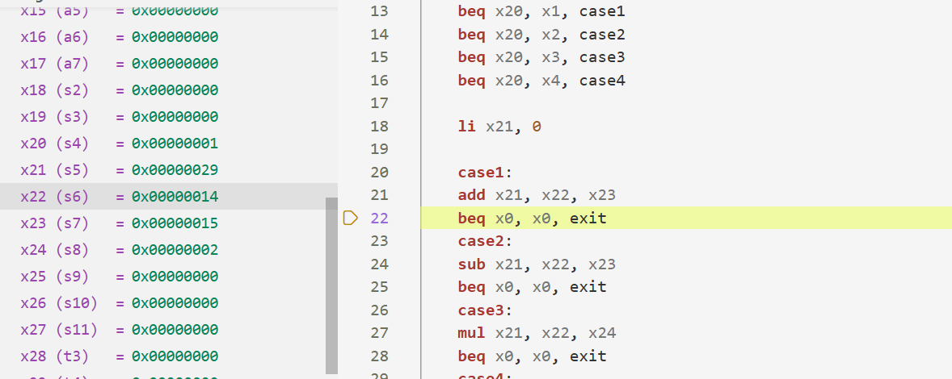

Case 2:
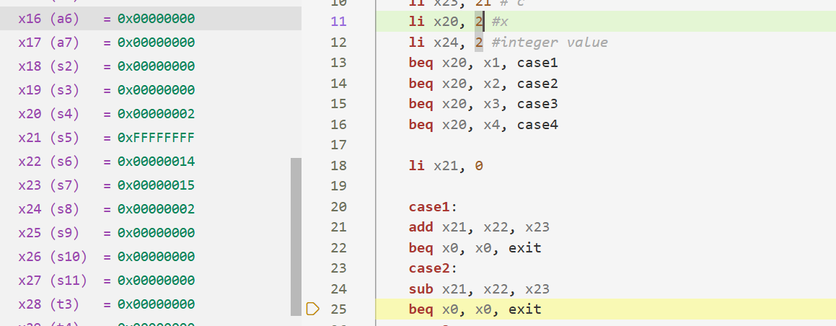

Case 3:
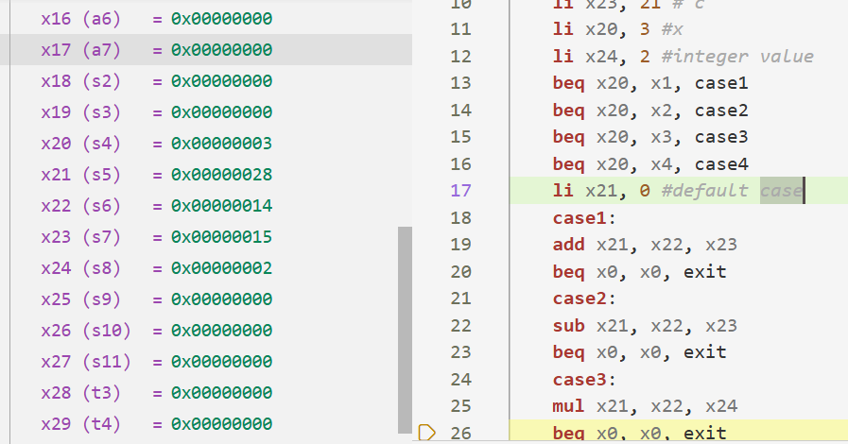
Case 4:
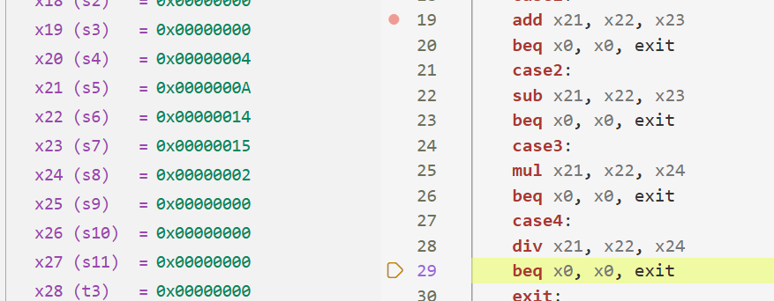

Task 3:
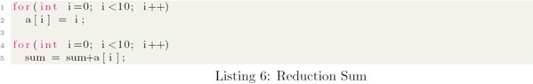
Write the equivalent RISC-V assembly code for Listing 6. Assume that the variables i and sum are in x22 and x23, while the array a located at address 0x200 is of 4-byte integers.

Code:
.text
.globl
main:
li t0, 0x200
li x25, 10
li x22, 0 #i=0
li x26, 0
li x23, 0 #sum=0
loop1:
bge x22, x25, loop2
slli x10, x22, 2
add t1, t0, x10
sw x22, 0(t1)
addi x22, x22, 1
j loop1

loop2:
bge x26, x25, end
slli x10, x26, 2
add t1, t0, x10
lw x24, 0(t1) # x24 = a[i]
add x23, x23, x24 #sum= sum + a[i]
addi x26, x26, 1
j loop2

end:

Output:
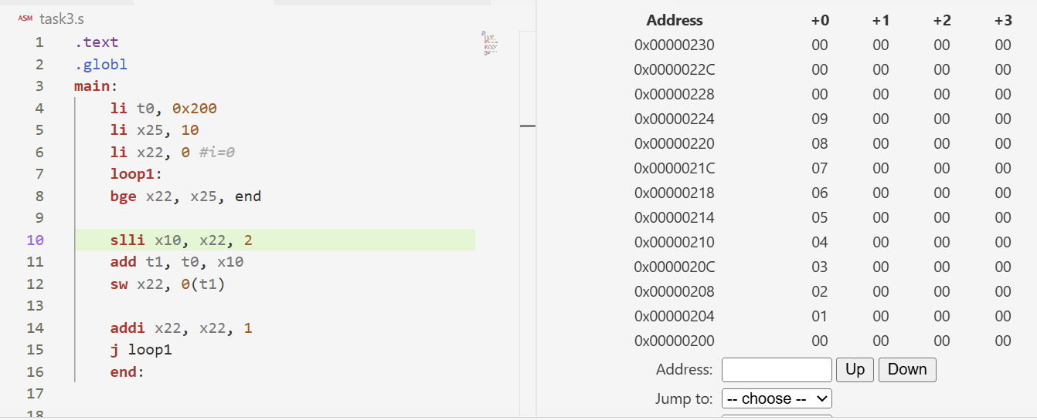

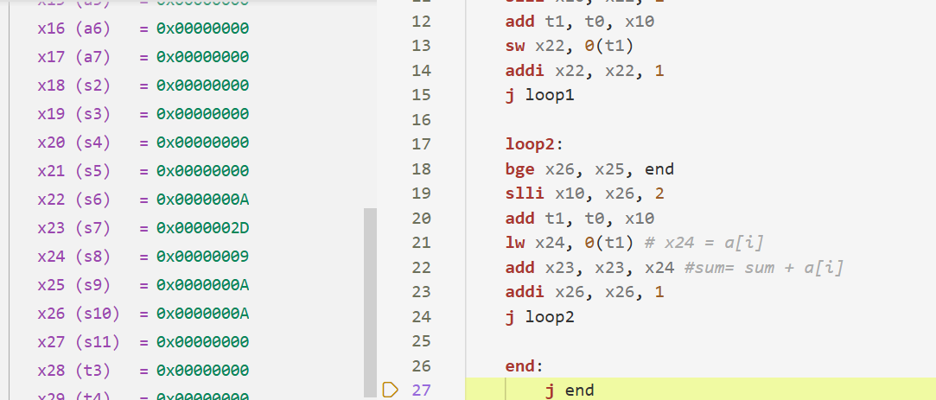

Task 4 (Challenge):
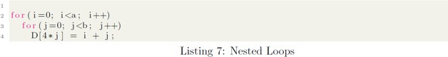
Translate the following C code to RISC-V assembly code. Use a minimum number of instructions. Assume that the values of a, b, i, and j are in registers x5, x6, x7, and x29, respectively. Also, assume that register x10 holds the base address of the array D.
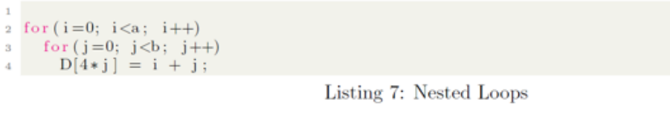
Code:
.text
.globl
main:
li x5, 2 # assuming a = 2
li x6, 3 #assuming b = 3
li x10, 0x200 # base address of D in memory

addi x7, x0, 0 # i = 0
i_loop:
bge x7,x5, end #i>=a

addi x29, x0, 0 # j = 0
j_loop:
bge x29, x6, next_i #j>=b

add x8, x7, x29 # x8 = i + j
slli x11, x29, 4 # x11 = j * 16 (4*j * 4 bytes)
add x11, x10, x11 # new calculated address (D[4*j])
sw x8, 0(x11) # D[4*j] = i + j
addi x29, x29, 1 # j++
j j_loop # repeat inner loop

next_i:
addi x7, x7, 1 # i++
j i_loop # repeat outer loop

end:
j end

Output
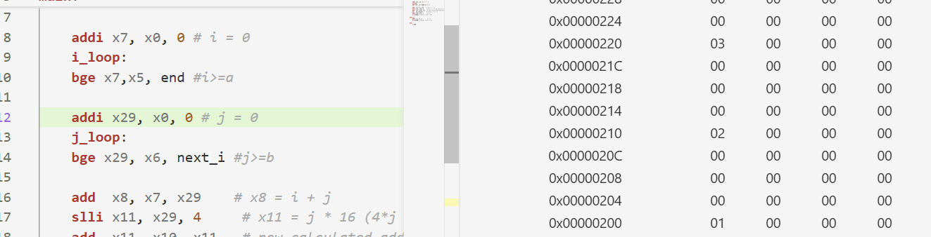
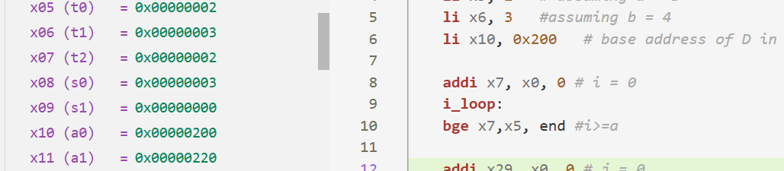

Assessment Rubric
Lab 2: Implementing Decision Instructions in RISC V Assembly Language

Name: Ayesha Mohammad Shahid  Syed Sualeh Abbas | Student ID:10278  10303 | Section: T4

Points Distribution

 | Task No. | LR 2  Code | LR 5  Results
In - Lab | Task 1 | /0 | /5
In - Lab | Task 2 | /10 | /10
In - Lab | Task 3 | /15 | /10
In - Lab | Task 4 | /20 | /10
Total Points: 100 |  | /45 | /35
CLO Mapped |  | CLO2

Affective Domain Rubric |  | Points | CLO Mapped
AR7 | Report Submission | /20 | CLO 2

CLO | Total Points | Points Obtained
2 | 100
Total | 100

For description of different levels of the mapped rubrics, please refer to the Lab Evaluation Assessment Rubrics and Affective Domain Assessment Rubrics provided here.

